Deleting by List Position

Look at this code:
tasks = ["email", "design", "test", "publish"]
position = int(input("Completed position 0 to 3: "))
completed = tasks[position]
del tasks[position]
print("Completed:", completed)
print("Remaining:", tasks)

What do you think this code will display?
Click or tap here to enter text.

Run the code. Compare the result with your prediction:
Click or tap here to enter text.

Let’s investigate! Answer the questions below:
- Why is the item stored before del removes it?
Click or tap here to enter text.

- What happens if del uses a position that does not exist?
Click or tap here to enter text.

- How do later positions change after an item is deleted?
Click or tap here to enter text.

- If you enter position 1, what are the exact Completed and Remaining lines?
Click or tap here to enter text.

Deleting by List Position

Look at this code:
tasks = ["email", "design", "test", "publish"]
position = int(input("Completed position 0 to 3: "))
completed = tasks[position]
del tasks[position]
print("Completed:", completed)
print("Remaining:", tasks)

Use the code above to help you. After completing each challenge below, run your program to test that it works correctly. Save each completed challenge program in a new file.

Programming Challenges

Challenge 1
Use position 0 as the completed task. The output must label email as completed and show the other three tasks in order.
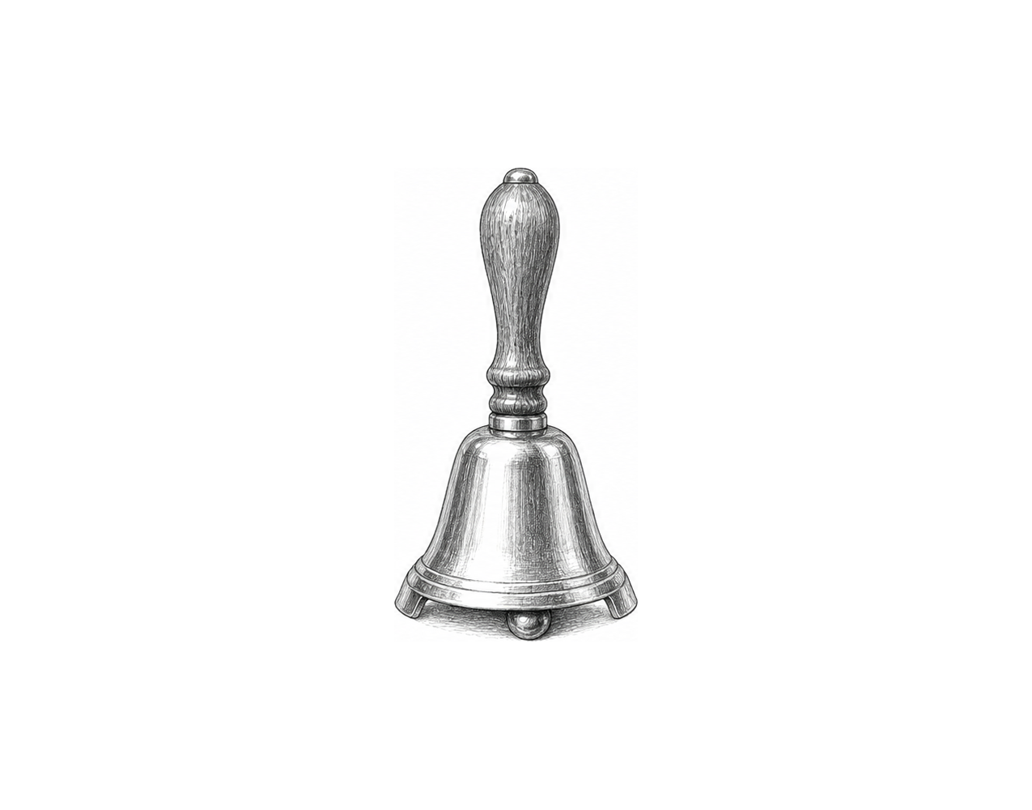

Challenge 2
After the first deletion, ask for a second valid position in the shortened list, label that item, delete it, and display what remains. Test first 1 then 1.

Challenge 3
Build a queue editor with four names. Ask for one valid cancellation position, store and delete that name, then traverse the remaining queue with numbered positions using a counter.

Deleting by List Position

Fix the code!

This code has errors! Look closely at the code to find the problems:

tasks = ["email", "design", "test", "publish"]
position = 2
completed = tasks(position)
del(tasks[position])
print(tasks)

Rewrite the whole program in the box below with fixes to the errors.
Click or tap here to enter text.

After you are confident that you fixed all the errors, copy the code from the box and run it.

Did it work correctly on your first try? Did you find all the errors?
Click or tap here to enter text.

